Project Requirement Specification – MediSure

**Technical Specification – Seller Functionalities**

**Modular Functionality** - Search Box Common Functionality

1. Clicking on suggestion will fill the search box and suggestions will hide
2. Clicking anywhere apart from suggestion box results into suggestion box being hidden

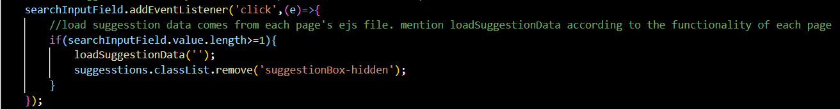

This peace of code handles the click event made on the search Box Input Field. If value length is greater than or equal to 1 then it displays the suggestion box. The loadSuggestionData is a function which is passed with ‘’ value to show the last suggestion box status. Ex. The name you viewed before clicking on one of them to add product. Its is such that **loadSuggestionData()** has a condition, that if input data length is less than 1 simply display the suggestion box else it process data before showing it to you.

Seller Home Page –

* Seller should be able to see their listed products.

**API Details**

Endpoint Name – seller/listed-products

Method – GET

Mandatory Data Needed to pass – NILL

Returned Data – Seller Data for header, set of 10 products

* Seller Search Box Functionality – defined in sellerHomePageSearchBarScripts.js

1. SellerHomePage.ejs contains a script which returns the name and product Id of all the products listed by seller.

Rationale – Each Item in suggestionList contains a name which is shown in UI and has corresponding product Id so when you search for product, the product Id is used to display specific product. **Also, it adds the result data into local Storage to reduce API calls.**

**Key Name –** *localStorageKey.suggestions*

1. Search Button –

**API Details**

Endpoint Name - seller/search-listed-product

Method -POST

Mandatory Data Needed to Pass – medicineId (ex. DRS102511).

Returned Data – medicine Name, type, use, manufacturer, price, quantity and product Id stored in checkbox to view details, edit product and delete which uses productId

1. GetAllProductButton event listener just re-renders the entire page.
2. searchInputField -> eventListner – input -> calls the loadSuggestionData(inputData) which provided suggestion list according to the input data.
3. *Function loadSuggestionData(inputData)*
4. If inputData length Is less than equal to 0, hide suggestionList and return
5. Else – Parses the localStorage data then filter the data according to the input in the sorted order. Once it is done, It is stored in such a fashion then medicine name who starts with the input data is displayed first followed by data in a sorted order.